Abstract Submission Form
International Symposium on Nano - Materials, Technology and Applications (NANOMATA), 15-17 October 2014, Hanoi, Vietnam
http://uet.vnu.edu.vn/nanomata2014/

Abstract Submissions: Opens 15 May 2014, and Closes 30 August 2014

Details of Presenting Author:
Title (Prof./Dr./…): Student
Last Name: Tran First Name: Hung
Job Title: Student Department: Vietnam National University, University of Engineering and Technology, Engineering Physics and Nanotechnology

Institution: University of Engineering and Technology, VNU
Correspondence Address: 144 Xuan Thuy street, Hanoi, Vietnam.
Country: Vietnam Postal Code: 10000
Tel: +84983248360 Fax:
E-mail: hungtv_560@vnu.edu.vn

Mode of Preferred Presentation:
□ Invited talk □ Oral Poster

Synthesis and characterization of Nanowire TiO₂ films

made by Hydrothermal Method
Hung V. Tran ^{(a, b, †)}, Long D. Pham ^{(a, ††)}
^{(a)} Institute of Materials Science, Vietnam Academy of Science and Technology.
Address: 18 Hoang Quoc Viet street, Hanoi 10000, Vietnam.

^{(b)} Vietnam National University, University of Engineering and Technology.
Address: 144 Xuan Thuy street, Hanoi 10000, Vietnam.

e-mail: †† longphd@ims.vast.ac.vn , † hungtv_560@vnu.edu.vn

Titanium dioxide (TiO₂) has been the most intensively investigated in recently because of their wide range applications such as photo catalysis, photovoltaic, lithium ion batteries, sensors, microwave absorbing materials, and biomedical treatments. In this work, TiO₂ nanowire films were successfully synthesized by a facile hydrothermal method by reaction of sputtered Ti films with high concentrated NaOH solutions. SEM images showed that the resulting films were porous networks of nanowires with nanowire diameters of about 15 nm. The influence of NaOH concentration and reaction temperature on the formation of nanowire TiO₂ films was studied. In addition, optical and photo-electrochemical properties of films were investigated and shown here.

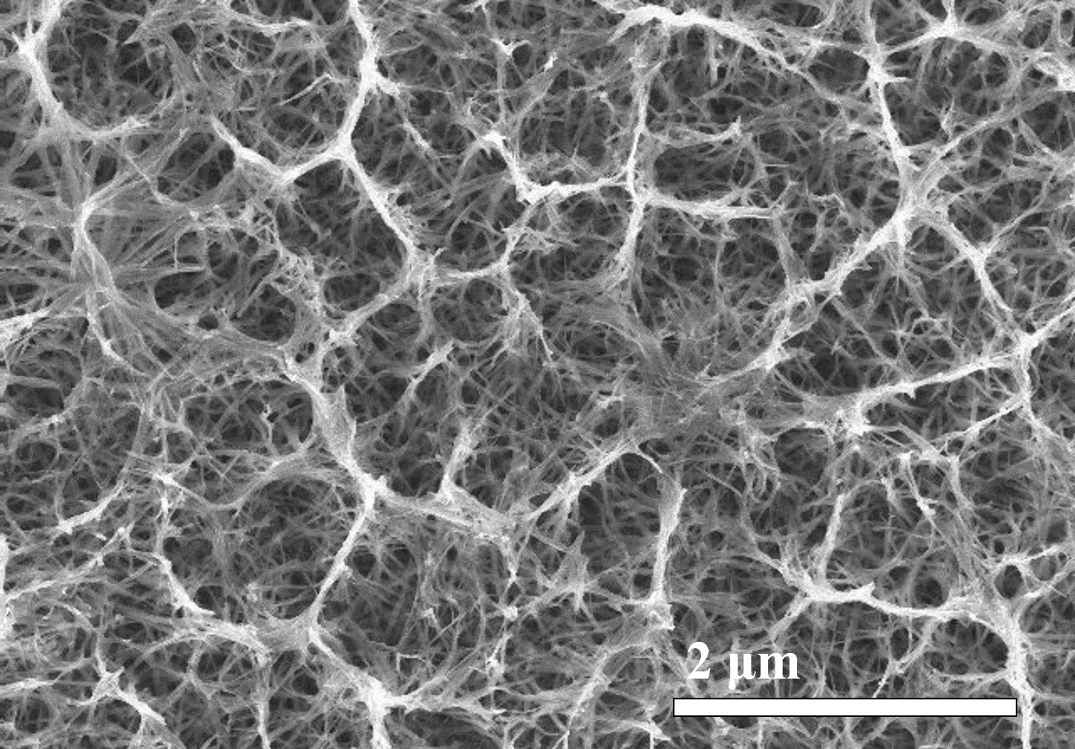 | Figure 1. FE-SEM images of as-synthesized TiO₂ nanowire films: Top view

Reference
[1] Jing-Zhi Chen, Wen-Yin Ko, Yin-Cheng Yen, Po-Hung Chen, and Kuan-Jiuh Lin, ACS Nano 6 (8), 6633, 6639 (2012).
[2] Wu-Qiang Wu, Bing-Xin Lei, Hua-Shang Rao, Yang-Fan Xu, Yu-Fen Wang, Cheng-Yong Su, and Dai-Bin Kuang, Sci. Rep. 3 (2013).

Keywords: TiO₂ nanowires, hydrothermal method, TiO₂ films, FTO, Ti film

